PIZZA SALES KPI
Revenue
select sum(total_price) from pizza_sales;
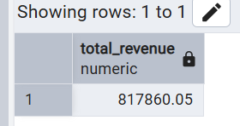

Total orders
select count(distinct order_id) AS Total_Orders from pizza_sales;
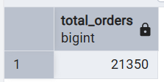

Average order value
select sum(total_price)/count(distinct order_id) AS Avg_Order_Value from pizza_sales;
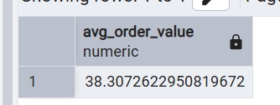

Total pizza sold
select sum(quantity) AS Total_Pizza from pizza_sales;
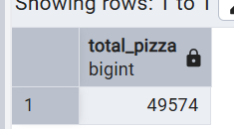

Average pizzas per order
select CAST (cast(sum(quantity) AS DECIMAL(10,2))/
CAST(count (distinct order_id) AS DECIMAL (10,2)) AS DECIMAL (10,2))
AS Avg_Price_Pizza 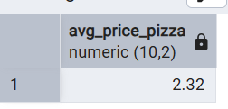
from pizza_sales;

Daily trend
SELECT TO_CHAR(order_date, 'Day') AS order_day,
COUNT(DISTINCT order_id) AS total_orders
FROM pizza_sales
GROUP BY order_day
Order BY order_day desc;
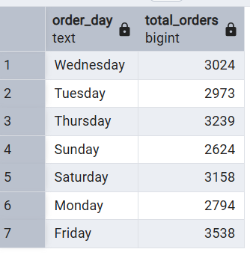

SELECT EXTRACT(HOUR FROM order_time) AS total_hours,
COUNT(DISTINCT order_id) AS total_orders
FROM pizza_sales
GROUP BY total_hours
ORDER BY total_hours;
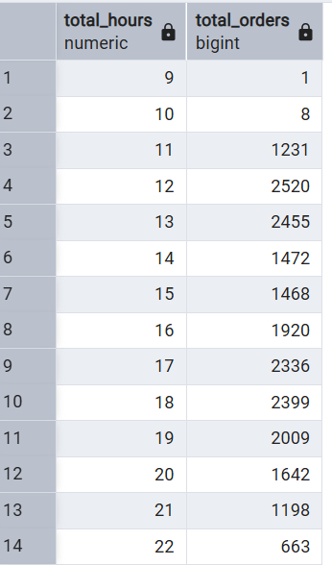

Total Pizzas sold by pizza_category
select pizza_category, sum(quantity)from pizza_sales
group by pizza_category
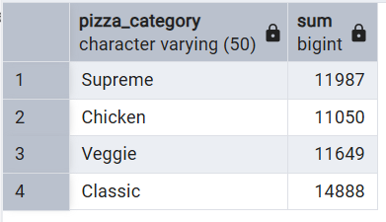

Top 5 pizza sold by name
select pizza_name , sum(quantity) as Total_pizzaname_sold
from pizza_sales
group by pizza_name
order by Total_pizzaname_sold desc
lIMIT 5

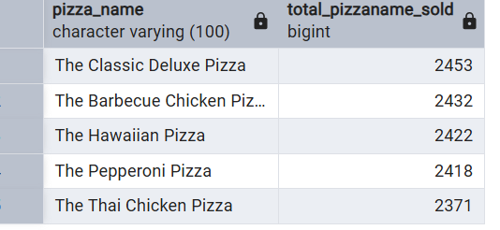

BOTTOM 5 PIZZA SOLD
select pizza_name , sum(quantity) as Total_pizzaname_sold
from pizza_sales
group by pizza_name
order by Total_pizzaname_sold ASC
lIMIT 5
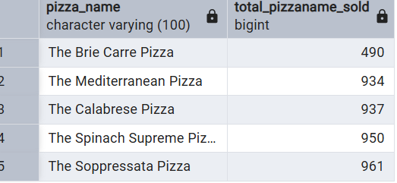

% of sales by pizza_category
SELECT pizza_category, sum(total_price) as Total_sales,sum(total_price) * 100 /(select sum(total_price)
from pizza_sales) AS Total_sales_revenue_pertge from pizza_sales
group by pizza_category

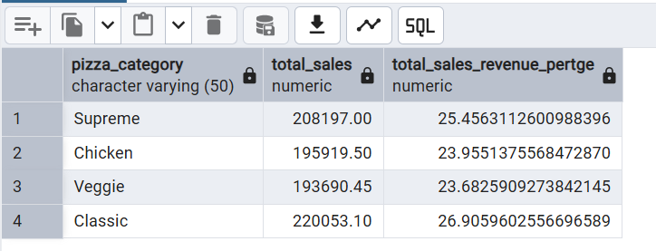

% of sales by pizza_category
SELECT pizza_size, sum(total_price) as Total_sales, CAST(sum(total_price) * 100 /(select sum(total_price)
from pizza_sales) AS DECIMAL (10,2))AS Total_sales_revenue_pertge from pizza_sales
group by pizza_size
order by Total_sales_revenue_pertge desc
